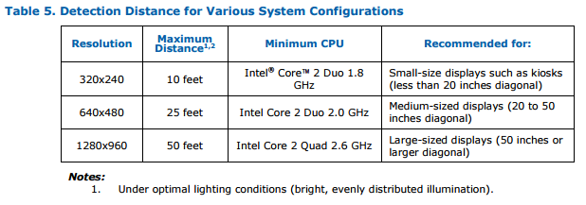
https://aimsuite.intel.com/intel-aim-store/files/AIMSuiteUserGuide.pdf
50 ft, 5ft/s, 2 seconds appropriate – 10 second absolute window
http://www.usroads.com/journals/p/rej/9710/re971001.htm

